Premium Brands (Online Store)

Database class project 2021/2022

|  |  |  |  |  |
| --- | --- | --- | --- | --- |
| Student Name in English | Student Name in Arabic | Student ID | Section | Work percentage |
| Alaa Samer Adnan Ajaj | الاء سامر عدنان عجعج | 11923705 | 11:00 - 12:30  Sun\Wed | 50% |
| Masa Monadel Noman Abdalhaleem | ماسه مناضل نعمان عبد الحليم | 11925122 | 9:30 – 11:00  Mon/Thu | 50% |
|  |  |  |  |  |

Date/time

---------------------------------------------This section is intended for the Instructor---------------------------------------

|  |  |
| --- | --- |
| **Topic** | **Mark** |
| Project Requirements and Modeling |  |
| Correctness of Database mapping |  |
| Functional Dependency and Normalization |  |
| Project Tools |  |
| Project Discussion |  |
| Project Completeness |  |
| Project Output Results or reporting (JasperReport, charts, graphs, etc.) |  |
| Project Administration and Management |  |
| Project Report |  |
| Project Idea |  |
| Project Complexity |  |
| Team work |  |
|  |  |
|  |  |
|  |  |

Abstract:

**Premium Brands** is an online store that offers products to online buyers, such as clothes, shoes, glasses and watches, where the buyer was able to sign in or sign up in this store via the application, then he can navigate between the existing items, choose the product he wants and add it to the shopping bag, then he will be shown his bill.

|  |  |
| --- | --- |
| Content | Page Number |
| Introduction | 3 |
| Project Requirement | 4 |
| Functional Dependency | 5 |
| Project UML | 7 |
| Tables in BCNF | 8 |
| Tools Used | 8 |
| GUI Discussion | 9 |
| SQL Statement | 18 |
| Jasper Report | 21 |
| Conclusion | 22 |
| References | 22 |

Introduction:

* We chose this project due to its frequent circulation in our lives and our great need for it. This program allows the buyer can buy without the need to go to places to buy, as it may be far from him or not be able to reach them, and to save time where with the push of a button he can get any product he wants.

Project Requirements:

* Store database that keeps track of the **products**, their **type** as well as the **users** and their information, The database also keeps track of the **shopping bag** that includes the **products** to be purchased by the buyer.
* For each **User**, the database maintains information of the User’s Name [UName], Personal Identification Number [U_ID], E-mail [UEmail], and Password [UPass], Phone Number [UPhone_Number], 2 Address [Address] (City, Street). Two **subclasses** of the **User** entity type are identified: **Buyer** and **Seller** we differentiated between them by [BuyerOrSeller] attribute.
* For each **Product**, the database maintains information of the Product’s Name [PName], Product’s Number [P#], Price [Price], Color [Color], Size [PSize], Image [PImage]. Each **Buyer** can buy a lot of **Products**, and Each **Product** can be bought by many **Buyers** if the available quantity of it is more than one. (So, the relationship is M:N) and Each **Seller** can manage all **Products**, and Each **Product** can be managed by the **Seller**, if there is more than one. (So, the relationship is M:N).
* For each **Type**, the database maintains information of the Type’s Name [TName] (like Clothes, Shoes, Watches, Glasses … etc.), Type’s Number [T_ID]. Each **Product** belongs to a specific **Type**, but it can be more than one **Product** of the same **Type.** (So, the relationship is M:1)**.**
* For each **Shopping Bag**, the database maintains information of the Item’s Number [Item#], Total price that should be paid [Total Price] and the information of the **Buyer** (like his Address, Phone Number … etc.) who wants to buy the **Products** that were placed inside this bag with the necessary information for it (like color, size … etc.). Each **Buyer** has one **Shopping Bag** and each **Shopping Bag** is for one **Buyer** only**.** (So, the relationship is 1:1) and One **Shopping Bag** can contain more than one **Product**, and the **Product** can be in more than one **Shopping Bag** if there is more than 1 quantity of the **Product.** (So, the relationship is M:N).

Functional Dependency:

* 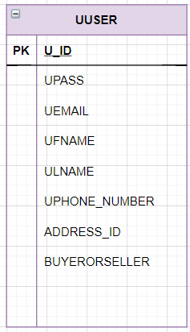User Table:

**U_ID 🡪 UPASS, UEMAIL, UFNAME, ULNAME, UPHONE_NUMBER, ADDRESS_ID, BUYERORSELLER**.

-----------------------------------------------------------------------------

* 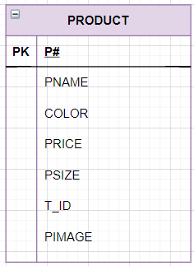Product Table:

**P# 🡪 PNAME, COLOR, PRICE, PSIZE, T_ID, PIMAGE**.

* 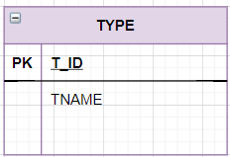Type Table:

**T_ID 🡪 TNAME**.

-----------------------------------------------------------------------------

* 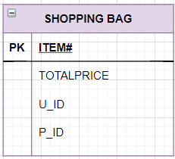Shopping Bag Table:

**ITEM# 🡪 TOTALPRICE, U_ID, P_ID**.

-----------------------------------------------------------------------------

* 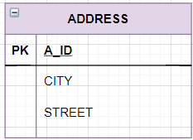Address Table:

**A_ID 🡪 CITY, STREET**.

-----------------------------------------------------------------------------

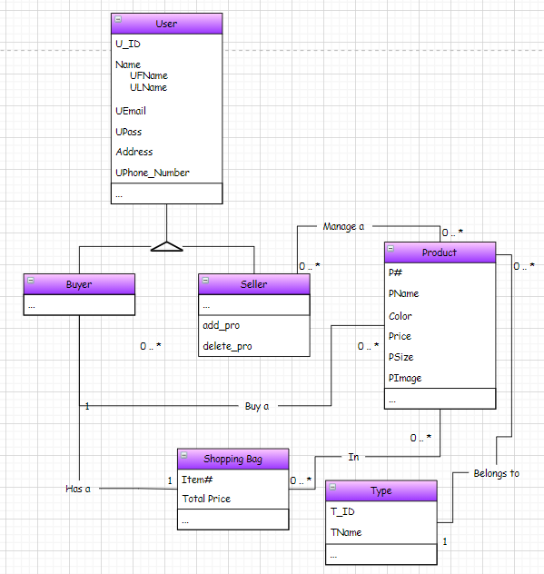Project UML:

Checking if the Tables in BCNF:

All tables are in BCNF.

* 1NF: they in which the intersection of every column and record contains only one value.
* 2NF: they don’t have any composite key.
* 3NF: there is no non primary key column is transitively dependent on the primary key.
* BCNF: every functional dependency Left Hand side is the super key of the table.

Tools Used:

1. Intellij as an IDE for Java.
2. Jasper soft studio for jasper report.
3. OracleXE184_Win64.
4. Draw.io for creating the initial Database UML.
5. Scene Builder for creating the FXML files used inside the JavaFX Project.
6. SQL Developer for connecting and creating the database tables and SQL Testing.
7. CSS for styling the interfaces in JavaFX.
8. Word documents.
9. Text documents.

GUI Discussion:

1. Main Page:

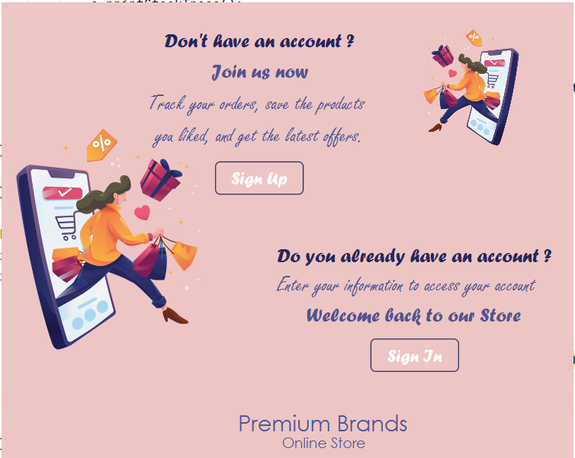Through this interface, the user can choose whether he wants to Sign-In or Sign-Up.

1. Sign Up Page:

On this page, if the user is new, he must enter his information in the appropriate places, then press the Sign-Up button and then take him to the Sign-In screen to verify his registration and then enter the store.

If he is not a new user, he can click on the Sign-In button at the bottom of Sign-Up screen to go to the Sign-In screen to enter through it.

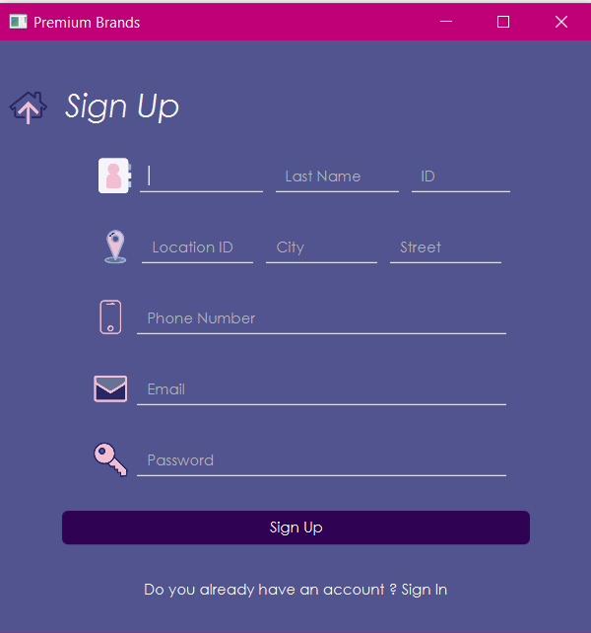

1. Sign In Page:

On this page, if the user is a previous user, he must enter his email that he previously registered with and the password in the appropriate places, then press the Sign-In button to enter the store.

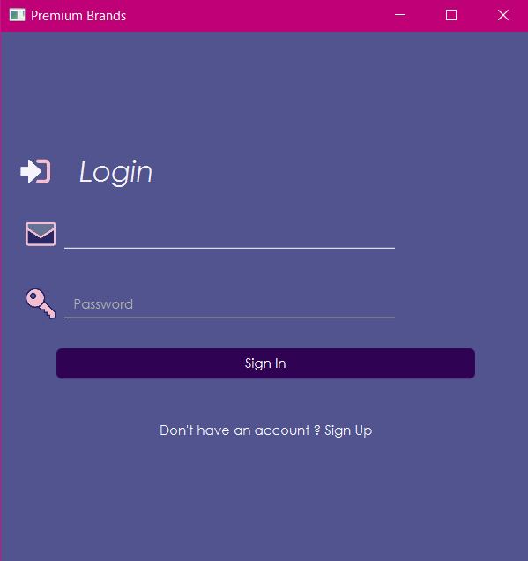If he is a new user, he can click on the Sign-Up button at the bottom of the Sign-In screen to move to the Sign-Up screen to enter his information and register.

If the admin’s email and password are entered, it will be transferred to another page through which the admin can see all the products in the store and their information and all the people registered in this store and their personal information



1. Start Page:

After signing in, this screen will be displayed where the user can choose the product he wants by clicking on one of these types, then the products will be shown to him according to their type.



1. Clothes, Shoes, Glasses, Watches Page:

When you click on this button, its screen will display and

contain the products belonging to it. Each product will display its specifications such as an image, name, color and size.

Then he can click on the Add To Shopping Bag button, and this product will be added to his cart







1. Shopping Bag Page:

This screen will display the products added by the user via the previous Add To Shopping Bag button, the total price and the price with delivery, then if he presses the Send Order button, the Bill will be displayed to him according to the Jasper Report.

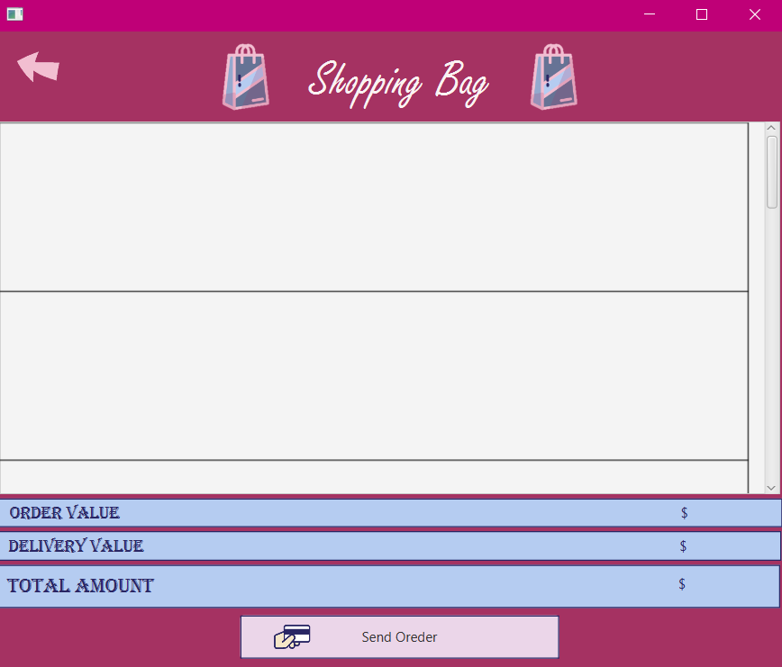

1. Account Page:

On this screen, the data of the user who entered the store is displayed, and he can modify it by deleting what he wants and writing the new information in the same place again and then pressing the Save Information button



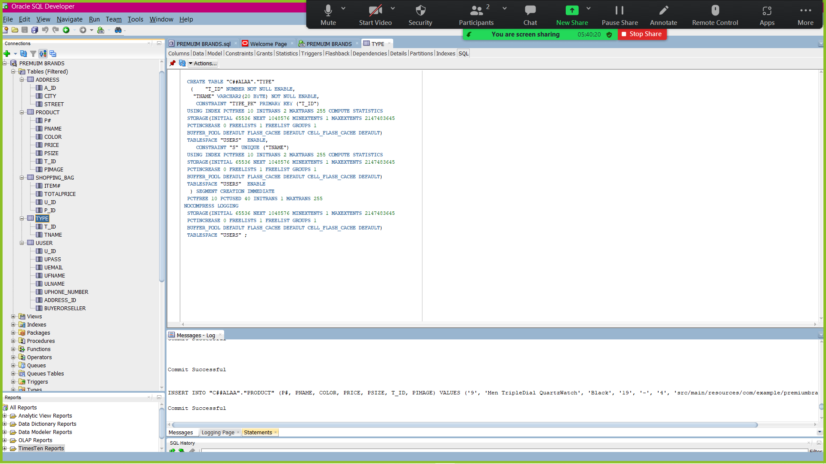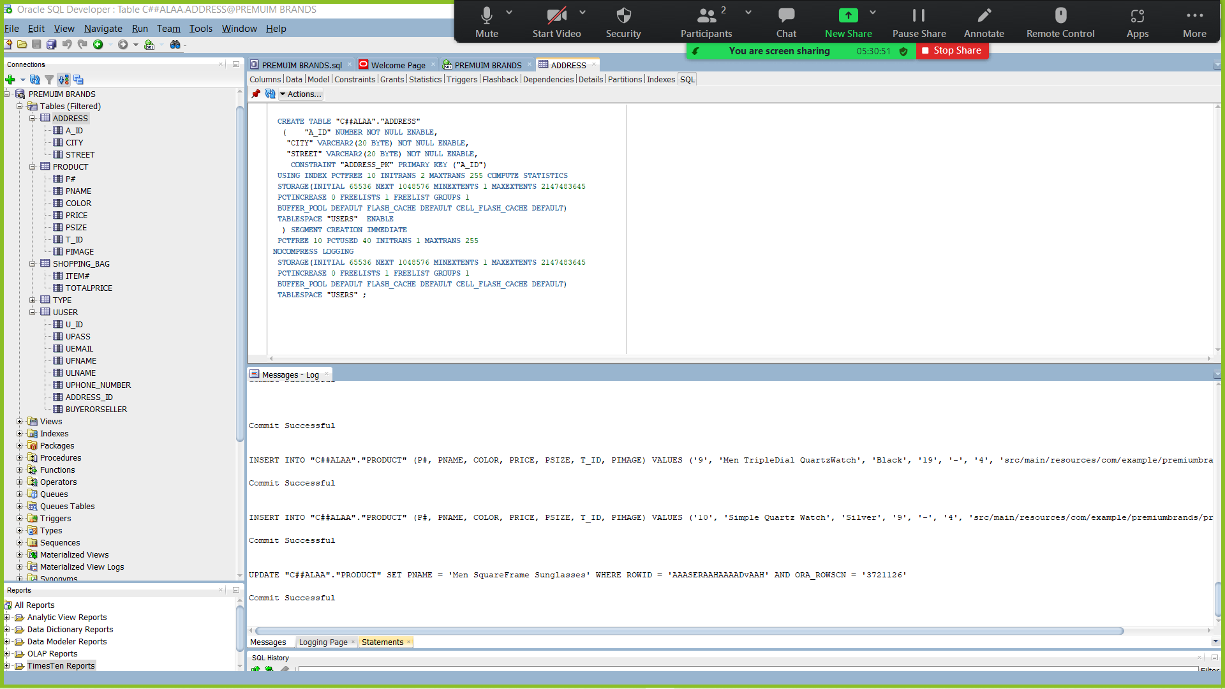SQL Statement:

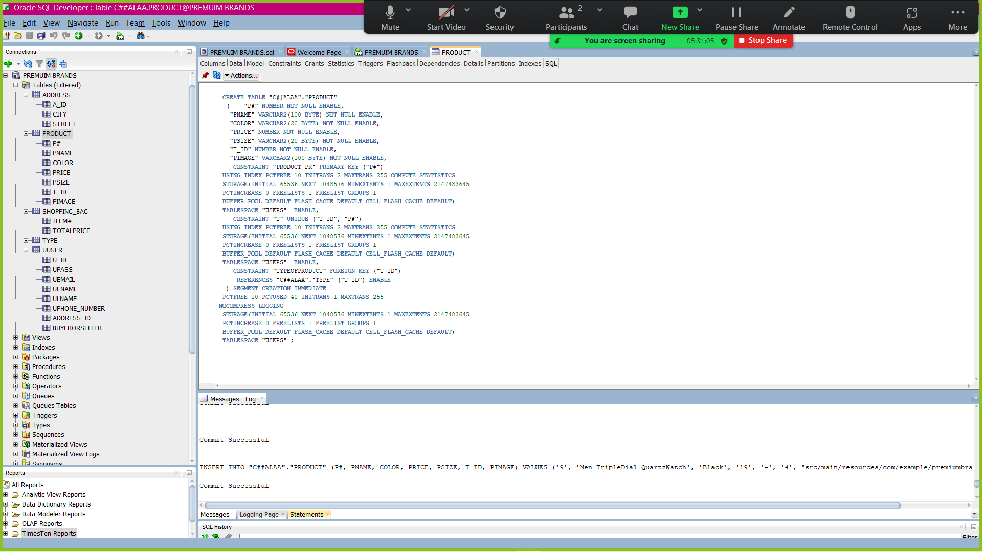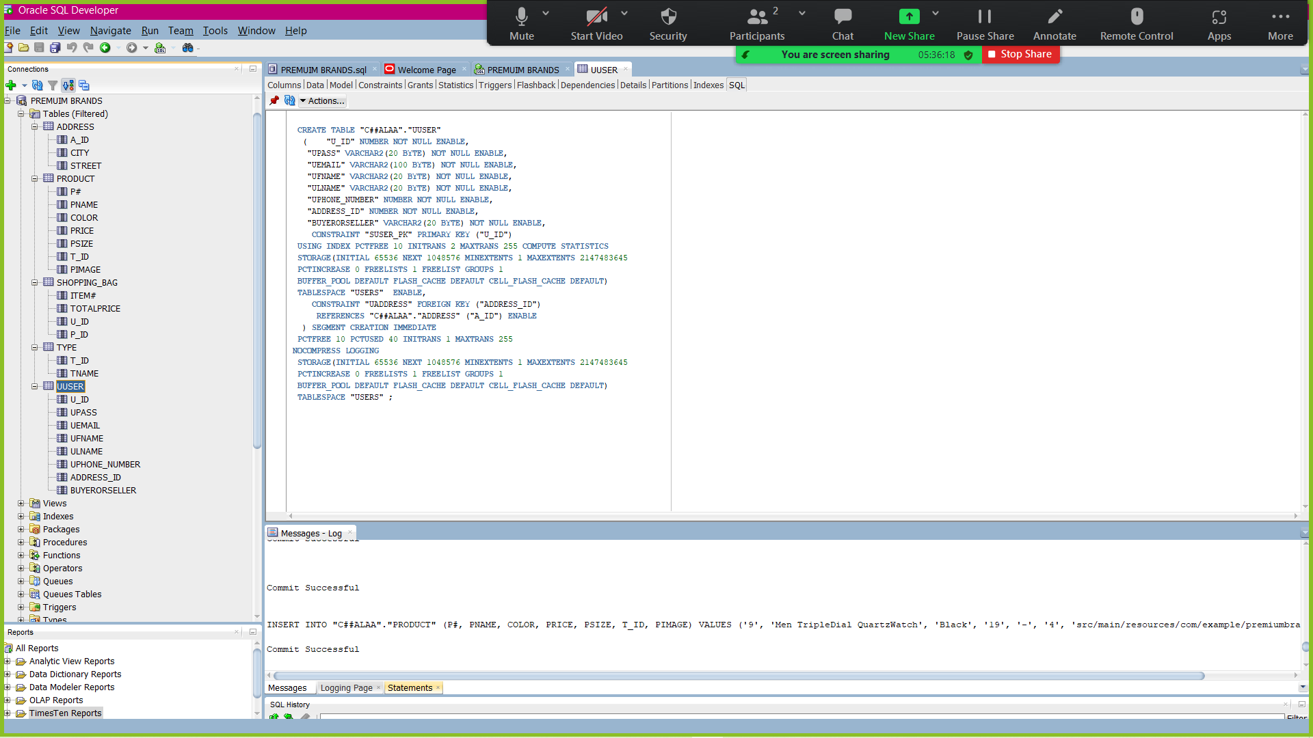

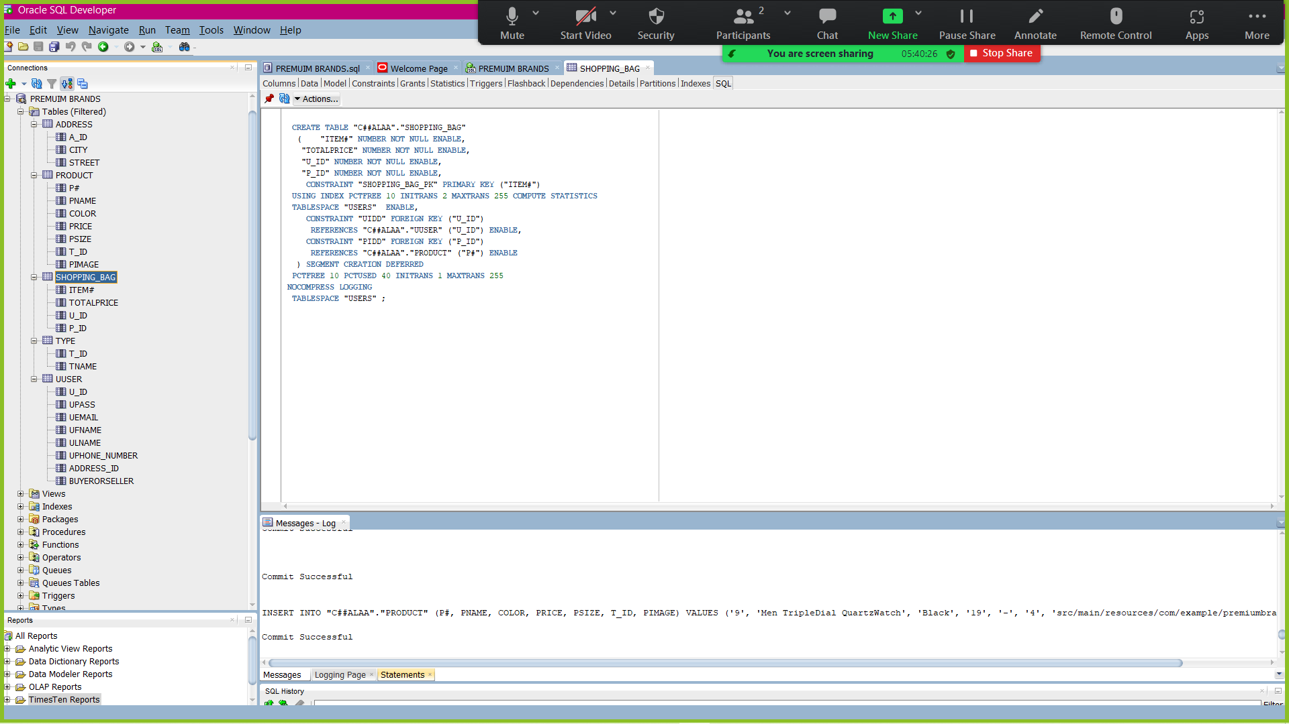

Jasper Report:

Conclusion:

This application helps its users to shop from their homes and from everywhere, and choose the product they want.

References:

* <https://imagecolorpicker.com/>
* <https://ezgif.com/maker>
* <https://www.tutorialspoint.com/how-to-display-an-image-in-javafx>
* <https://loading.io/icon/>
* <https://ar.shein.com/>
* <https://youtu.be/wxhGKR3PQpo>
* <https://youtu.be/SKyDoyAZyOo>